Bubble Struggle

# http://www.bubblestruggle.co/wp-content/uploads/2012/07/33.jpgPhase 1 task 1

1. The game I chose to recreate is called Bubble Struggle a 2D game where the player has to shoot these bubbles that when they exploded they split into more bubbles of a smaller size before they hit the player and kill him. I used a you tube video for a tutorial from the you tuber Brackeys where he creates a simple version of the game.

# Task 2

Using your research as basis, create specifications (a design brief of **up to two pages**) for the

mechanics and visual assets required to bring your game to life. Include at least:

1. **Target Device:** The target device is the computer because it uses the keyboard and mouse for movement and shooting.
2. **Gameplay Flowcharts :**

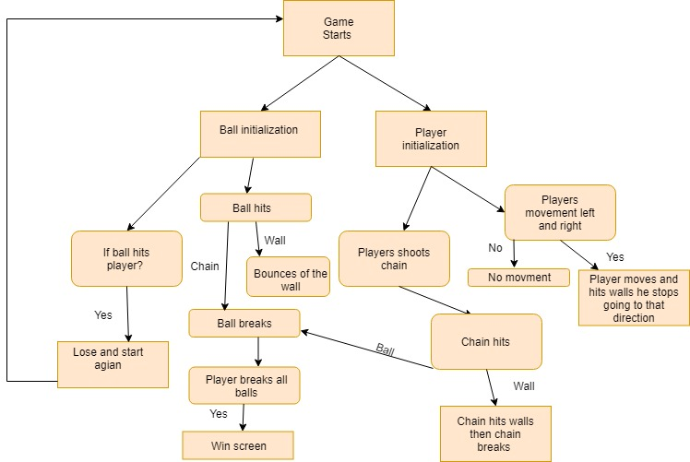

1. **Game Mechanics :**

Shooting the bouncing ball that will then split into smaller balls

1. **Game Objectives, if any**

Destroy the entire ball

1. **Visual Assets (2D / 3D)**
2. **UI Elements**
3. **Game Scenes**

<http://www.rebubbled.com/>

<https://www.youtube.com/watch?v=4jGVesn7O4g&t=2476s>